SCHOOL OF COMPUTER SCIENCES

UNIVERSITI SAINS MALAYSIA

CPT443 Automata Theory and Formal Languages

Semester 2 2021/2022

Title: Assignment 1 – DFA Place Finder

Student: Teh Zhen Rong (143955)

Table of Contents

1 Introduction 2

2 Implementation Information 2

2.1 Reading of input string 2

2.2 Overview of programming construct 4

3 Conclusion 4

4 Appendix – Sample/Full programs 5

4.1 DFA 5

4.2 GUI 6

4.3 Dictionary Used 8

# Introduction

The language will accept characters ‘abcdefghijklmnopqrstuvwxyzABCDEFGHIJKLMNOPQRSTUVWXYZ ’.

The language consists of district names and states in Malaysia like Butterworth, Alor Setar, Balik Pulau, Kedah, Penang, and Perak. The language also consists of country names that are member states of the United Nations. Moreover, the language also consists of continents of Earth following Wikipedia. The language will accept strings that only contain in the dictionary which are the district names in Malaysia, country name and continents of Earth. There are about 450 district strings in the dictionary that is created.

The DFA will accept the string that consists of the string in the dictionary as a whole and give strings that is otherwise trap state or not accepting state. The simple illustration of the DFA is shown in the following figure.

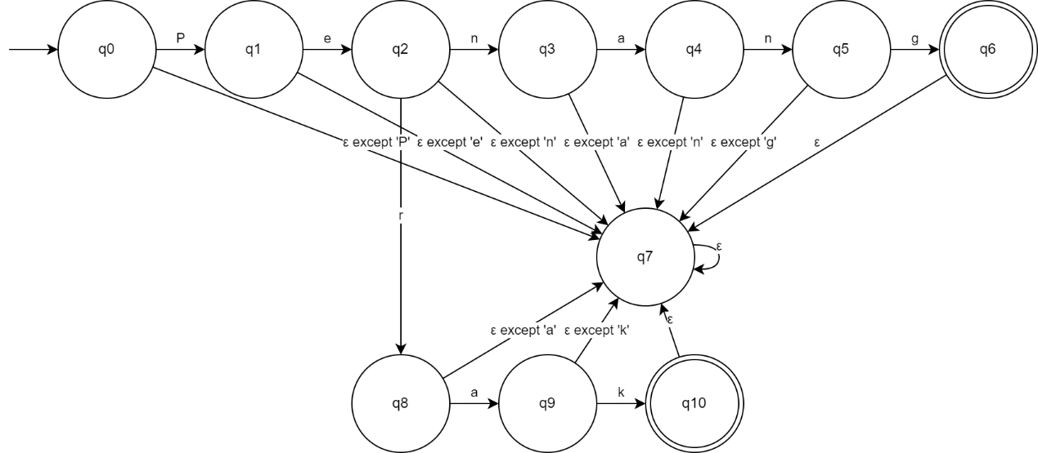

Figure Sample of DFA

In Figure 1, the language accepts only string ‘Penang’ and ‘Perak’ and reject other strings.

# Implementation Information

The DFA machine is implemented using Python. This is because of Python is great for fast prototyping and having large numbers of libraries.

## Reading of input string

The input of strings can be two form which are as keyboard inputs and txt files. Both forms are read by the program and store a string. The string is then gone through a for loop to get character by character out from the string starting from left to right, top to bottom. Each character is inputted into the DFA machine and get the results of each character that is inputted. The inputted strings are then determined accepted or rejected when the character is whitespace, commas, and full stop. The inputted strings consist of many words. The DFA will accept character by character of the first word and determine whether to continue forward to next word if there are possible state that come after the first word. If the first two words are accepted and there still have possible state come after the first two word the DFA will continue to get input from the third word. These all are done character by character. If the process breaks at midway of second word, the first word that is accepted by DFA will be treat as accepted by DFA and the DFA is initiated for inputting the second word character by character again.

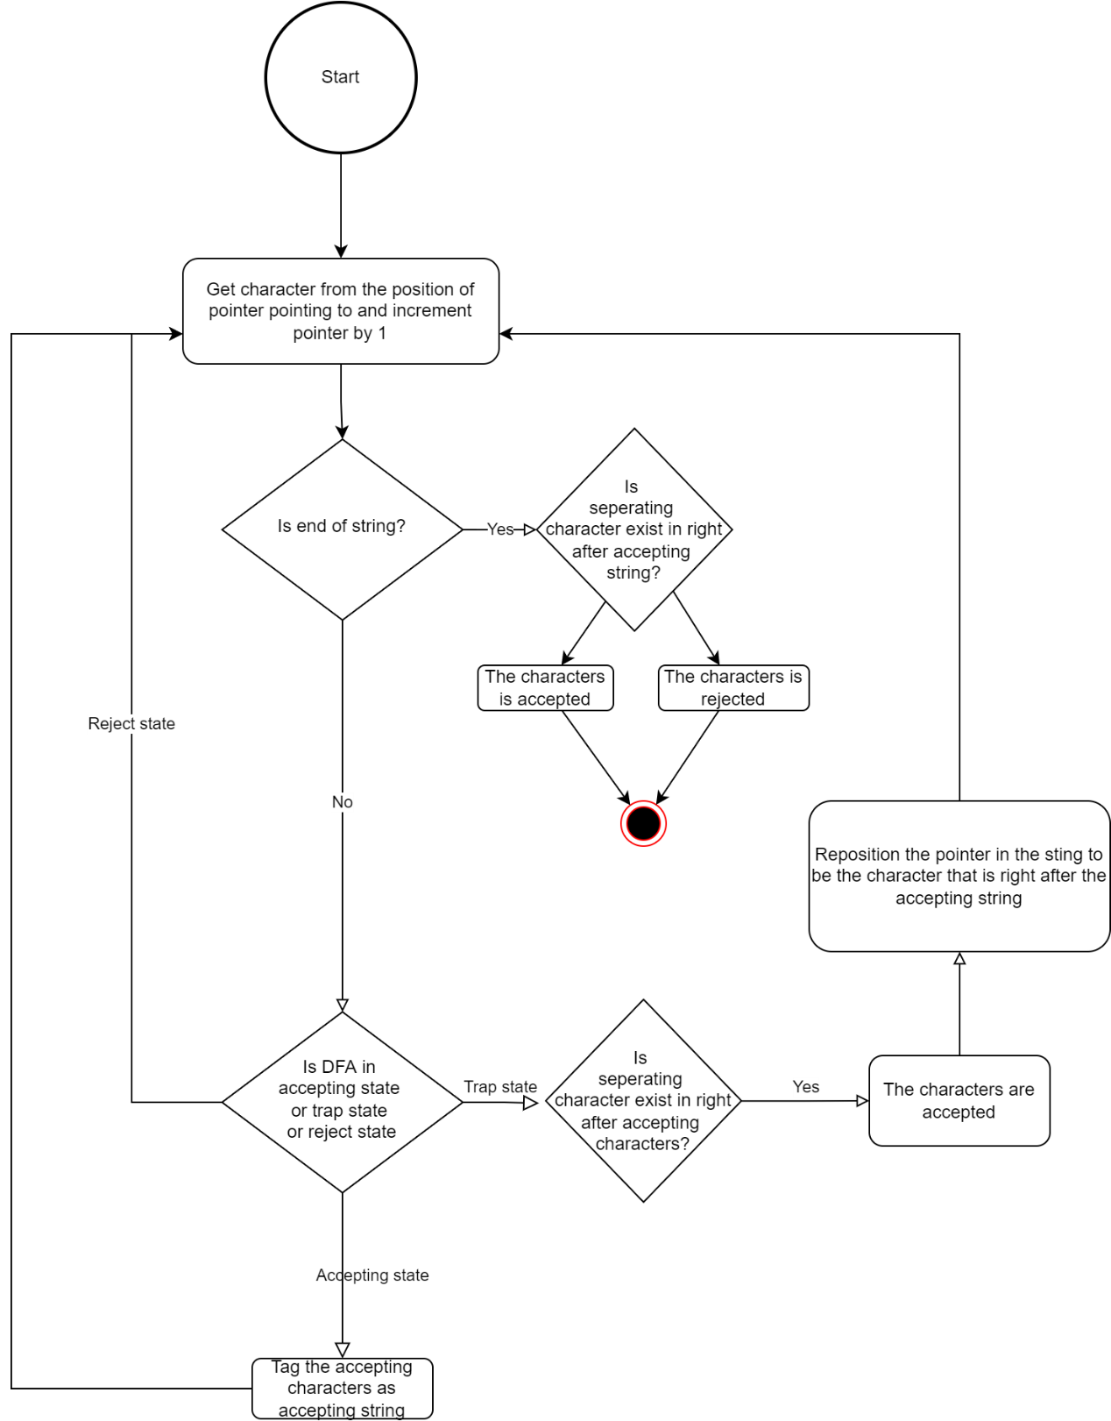

Figure Flowchart of Reading Input String

## Overview of programming construct

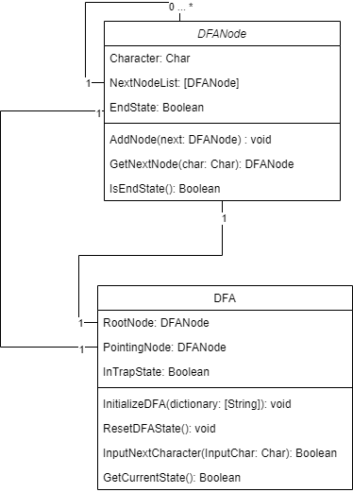

Figure Class Diagram of DFA

The overall DFA consists of 2 parts which are DFA class and DFANode class. The other module like the GUI does not discuss in this part.

The DFA class has a RootNode which act as a pointer that pointing at the start state of DFA. The PointingNode act as a pointer that pointing at the current state of the DFA which will move from one state to another state according to the input character.

A DFANode consists of a list of DFANode inside it which act as a transition function of a particular state in DFA. DFANode can only move from one state to another using the NextNodeList only.

# Conclusion

Throughout the assignment, I have learnt into depth of building DFA from scratch using Python. The scope of this assignment is also limited due to the amount of clean data I able to manage and get and the computational resources required by the program to run a larger scope.

Due to nature of Python I unable to have a better solution than the current one that I implemented where the pointer is unable to be implemented. In the end, the Python program of DFA is looked like a NFA where not every character of the character consider in language is stated in the transition function but I managed to make into mocking a DFA machine by assuming all character that in not stated in the transition function are moved to a trap state.

# Appendix – Sample/Full programs

## DFA

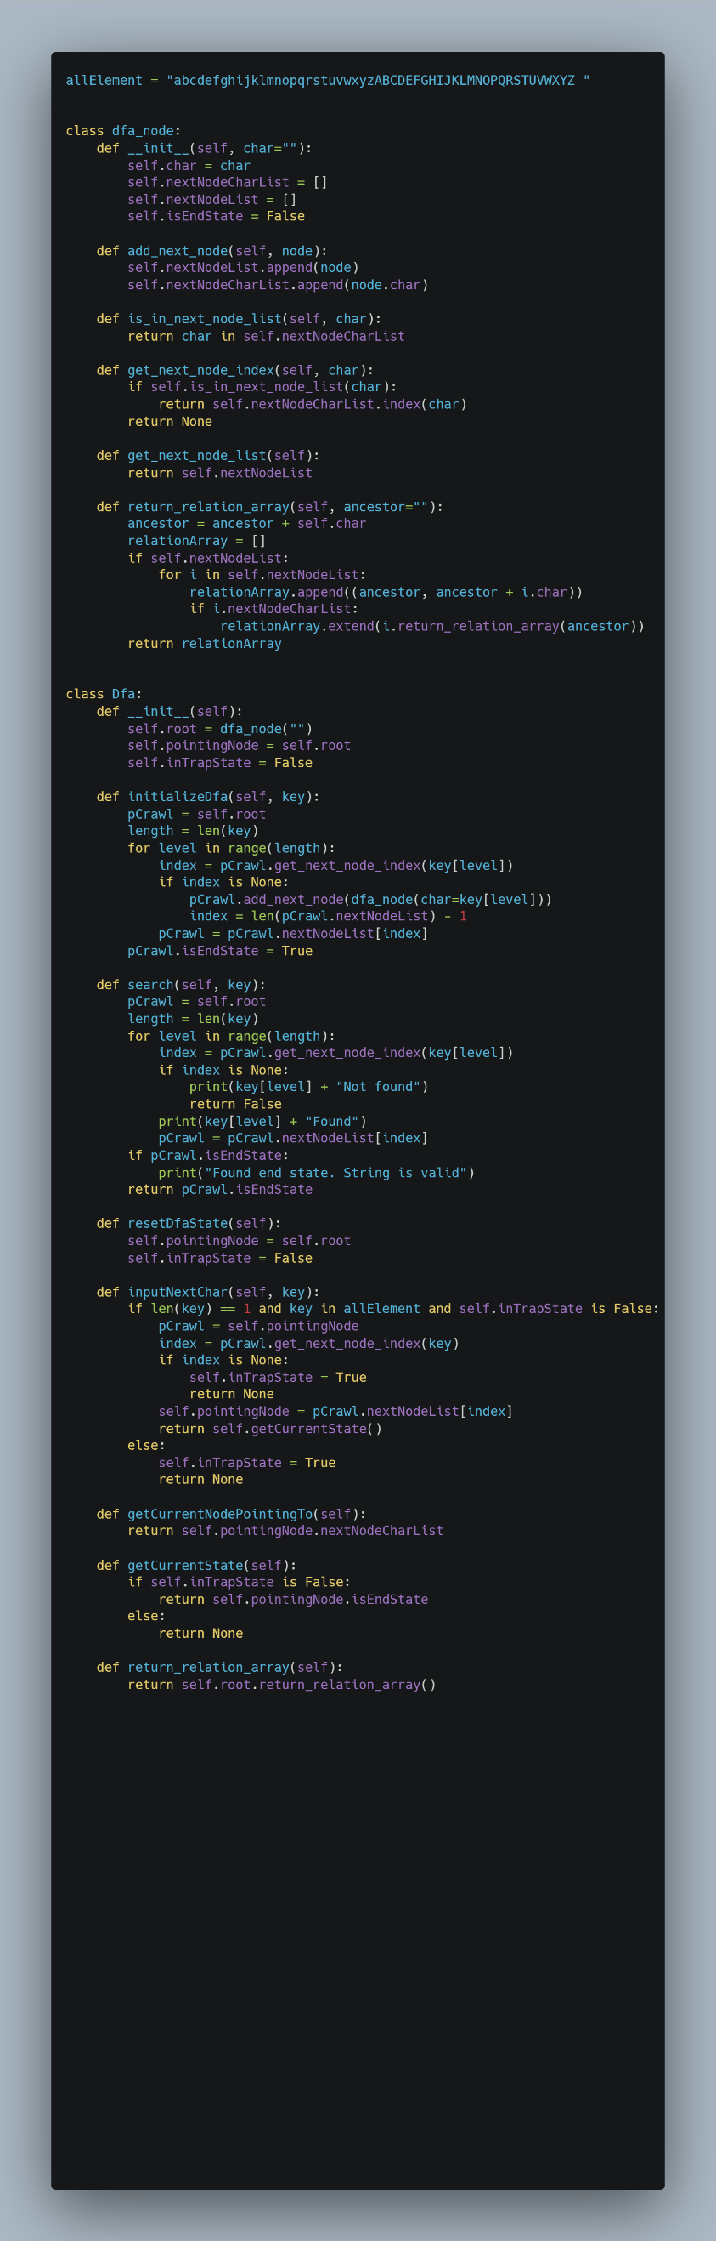

## GUI

## Dictionary Used

Alor Gajah

Alor Setar

Asajaya

Bachok

Bagan Datuk

Bakong

Balik Pulau

Baling

Bandar Baharu

Bandar Baru Bangi

Bandar Baru Selayang

Bandar Bera

Bandar Permaisuri

Bandar Seri Jempol

Batang Padang

Batu Gajah

Batu Pahat

Bau

Beaufort

Belaga

Belawai

Beluran

Beluru

Bentong

Bera

Besut

Betong

Bintangor

Bintulu

Bukit Mabong

Bukit Mabong[6]

Bukit Mertajam

Cameron Highlands

Central Seberang Perai

Chukai

Dalat

Daro

Dungun

Federal Territory (Malaysia)

George Town

Gerik

Gombak

Gua Musang

Hilir Perak

Hulu Langat

Hulu Perak

Hulu Selangor

Hulu Terengganu

Interior

Jasin

Jelebu

Jeli

Jempol

Jerantut

Jitra

Johor

Johor Bahru

Julau

Kabong

Kalabakan

Kampar

Kampung Raja

Kangar

Kanowit

Kapit

Kedah

Kelantan

Kemaman

Keningau

Kepala Batas

Kerian

Kinabatangan

Kinta

Klang

Kluang

Kota Belud

Kota Bharu

Kota Kinabalu

Kota Marudu

Kota Setar

Kota Tinggi

Kuah

Kuala Berang

Kuala Dungun

Kuala Kangsar

Kuala Klawang

Kuala Krai

Kuala Kubu Bharu

Kuala Langat

Kuala Lipis

Kuala Lumpur

Kuala Muda

Kuala Nerang

Kuala Nerus

Kuala Penyu

Kuala Pilah

Kuala Rompin

Kuala Selangor

Kuala Terengganu

Kuantan

Kubang Pasu

Kuching

Kudat

Kulai

Kulim

Kunak

Labuan

Lahad Datu

Langkawi

Larut, Matang and Selama

Lawas

Limbang

Lipis

Long Lama

Lubok Antu

Lundu

Machang

Malacca

Malacca City

Malaysia

Manjung

Maran

Marang

Marudi

Matu

Melaka Tengah

Meradong

Mersing

Miri

Muallim

Muar

Mukah

Nabawan

Negeri Sembilan

North Seberang Perai

Northeast Penang Island

Padang Terap

Pahang

Pakan

Papar

Parit Buntar

Pasir Mas

Pasir Puteh

Pekan

Penampang

Penang

Pendang

Perak

Perak Tengah

Perlis

Petaling

Pitas

Pokok Sena

Pontian

Pontian Kechil

Port Dickson

Pusa

Putatan

Putrajaya

Ranau

Raub

Rembau

Rompin

Sabah

Sabak

Sabak Bernam

Salak Tinggi

Samarahan

Sandakan

Saratok

Sarawak

Sarikei

Sebauh

Segamat

Selangau

Selangor

Semporna

Sepang

Serdang

Seremban

Seri Iskandar

Seri Manjung

Serian

Setiu

Sibu

Sik

Simanggang

Simunjan

Sipitang

Song

South Seberang Perai

Southwest Penang Island

Sri Aman

Subang

Subis

Sungai Jawi

Sungai Petani

Taiping

Tambunan

Tampin

Tanah Merah

Tanah Rata

Tangkak

Tanjung Malim

Tanjung Manis

Tapah

Tatau

Tawau

Tebedu

Telang Usan

Teluk Datok

Teluk Intan

Telupid

Temerloh

Tenom

Terengganu

Tongod

Tuaran

Tumpat

Victoria

West Coast

Yan

Yan Besar

Afghanistan

Albania

Algeria

Andorra

Angola

Antigua and Barbuda

Argentina

Armenia

Australia

Austria

Azerbaijan

Bahamas

Bahrain

Bangladesh

Barbados

Belarus

Belgium

Belize

Benin

Bhutan

Bolivia

Bosnia and Herzegovina

Botswana

Brazil

Brunei

Bulgaria

Burkina Faso

Burundi

Côte d'Ivoire

Cabo Verde

Cambodia

Cameroon

Canada

Central African Republic

Chad

Chile

China

Colombia

Comoros

Congo

Congo-Brazzaville

Costa Rica

Croatia

Cuba

Cyprus

Czechia

Czech Republic

Democratic Republic of the Congo

Denmark

Djibouti

Dominica

Dominican Republic

Ecuador

Egypt

El Salvador

Equatorial Guinea

Eritrea

Estonia

Eswatini

Ethiopia

Fiji

Finland

France

Gabon

Gambia

Georgia

Germany

Ghana

Greece

Grenada

Guatemala

Guinea

Guinea-Bissau

Guyana

Haiti

Holy See

Honduras

Hungary

Iceland

India

Indonesia

Iran

Iraq

Ireland

Israel

Italy

Jamaica

Japan

Jordan

Kazakhstan

Kenya

Kiribati

Kuwait

Kyrgyzstan

Laos

Latvia

Lebanon

Lesotho

Liberia

Libya

Liechtenstein

Lithuania

Luxembourg

Madagascar

Malawi

Maldives

Mali

Malta

Marshall Islands

Mauritania

Mauritius

Mexico

Micronesia

Moldova

Monaco

Mongolia

Montenegro

Morocco

Mozambique

Myanmar

Namibia

Nauru

Nepal

Netherlands

New Zealand

Nicaragua

Niger

Nigeria

North Korea

North Macedonia

Norway

Oman

Pakistan

Palau

Palestine State

Panama

Papua New Guinea

Paraguay

Peru

Philippines

Poland

Portugal

Qatar

Romania

Russia

Rwanda

Saint Kitts and Nevis

Saint Lucia

Saint Vincent and the Grenadines

Samoa

San Marino

Sao Tome and Principe

Saudi Arabia

Senegal

Serbia

Seychelles

Sierra Leone

Singapore

Slovakia

Slovenia

Solomon Islands

Somalia

South Africa

South Korea

South Sudan

Spain

Sri Lanka

Sudan

Suriname

Sweden

Switzerland

Syria

Tajikistan

Tanzania

Thailand

Timor-Leste

Togo

Tonga

Trinidad and Tobago

Tunisia

Turkey

Turkmenistan

Tuvalu

Uganda

Ukraine

United Arab Emirates

United Kingdom

United States of America

Uruguay

Uzbekistan

Vanuatu

Venezuela

Vietnam

Yemen

Zambia

Zimbabwe

Africa

Antarctica

Asia

Europe

North America

South America

Afro-Eurasia

Americas

Eurasia

Oceania

Amazonia

Arctica

Asiamerica

Atlantica

Avalonia

Baltica

Cimmeria

Congo Craton

Euramerica

Kalaharia

Kazakhstania

Laramidia

Laurentia

North China

Siberia

South China

East Antarctica

Pampia

Cuyania

Chilenia

Southeast Asia